QUANTUM CYBERSECURITY SKILLS RESELLER PARTNER AGREEMENT
Reseller Agreement Level: <ENTER FROM PARTNER PROGRAM>
Reseller Name: <ENTER LEGAL COMPANY NAME>
Address/City/State/Postcode/Country: <ENTER COMPANY ADDRESS>
Quantum Cybersecurity Skills Reseller Authorization Number: _______________________________
This Agreement is between Quantum Cybersecurity Skills Limited (“QCS”) and the reseller partner named above (“Reseller”) and establishes the terms and conditions for Reseller’s participation in the QCS Reseller Program (the “Program”). Under the Program, QCS will provide marketing and promotional support to Reseller as specified in this Agreement related to Reseller’s resell of the QCS Professional Security Services and Education Program.

- Reseller Qualification
  - In order to ensure adequate technical and marketing support to end users, eligibility to resell QCS Professional Security Services and Education Program is subject to meeting certification requirements as described in the Certification Requirements attached hereto as Appendix B.

- Relationship
  - Reseller is an independent contractor engaged in promoting the QCS Professional Security Services and Education Program for resale to its customers. Reseller is not an agent or legal representative of QCS for any purpose, and has no authority to act for, bind or commit QCS.
  - Reseller has no authority to make any commitment on behalf of QCS with respect to quantities, delivery, modifications, interfacing capability (if any), suitability of services and/or product. Reseller has no authority to modify the warranty offered with the QCS Professional Security Services and Education Program. Reseller will indemnify QCS from liability for any modified warranty or other commitment by Reseller not specifically authorized by QCS.
  - Reseller will not represent itself in any way that implies Reseller is an agent or branch of QCS; Reseller will immediately change or discontinue any representation or business practice found to be misleading or deceptive by QCS immediately upon notice from QCS.
3. Term, Limitations, Termination
  - The term of this Agreement is twelve (12) months from the date of acceptance by Reseller and QCS. This Agreement shall automatically renew on each subsequent year for a one-year term contingent on meeting the Required Sales Target described in Appendix A, unless it is terminated earlier in accordance with this Agreement.
  - QCS or Reseller may terminate this Agreement without cause at any time upon thirty (30) days written notice or with cause at any time upon fifteen (15) days written notice, except that neither the expiration nor earlier termination of which has accrued as of the date of termination.
  - QCS may, from time to time, give Reseller written notice of amendments to this Agreement. Any such amendment will automatically become a part of this Agreement thirty (30) days from the date of the notice, unless otherwise specified in the notice.
  - Upon expiration, non-renewal or termination of this Agreement, all interests in accrued marketing funds (if any) will automatically lapse.

- Reseller Program
  - QCS’s Reseller program will have a regional focus. Each Reseller may only sell the QCS Professional Security Services and Education Program within his designated sales region.
  - QCS may invite Reseller from time to time to participate in the co-operative advertising, market development and promotional programs offered by QCS. Reseller may, at its option, participate in such programs during the term of this Agreement. QCS reserves the right to terminate or modify such programs at any time at its sole discretion.
  - Reseller shall exert best efforts to market the QCS Professional Services and Education Program and shall use all promotional materials supplied by QCS. It is Reseller’s responsibility to help its customers determine which service and/or product would best serve their needs.
  - As defined in the Program Materials, Reseller shall have sufficient technical knowledge of the QCS Professional Security Services and Education Program in general, and will have access to appropriate QCS sales and technical training.
  - QCS does not represent that it will continue to develop and sell QCS Professional Security Services and Education Program indefinitely or even for any specific period. QCS specifically reserves the right to modify any of the specifications or characteristics of its services and/or products, to remove any services and/or product from the market, and/or to cease developing or supporting it.
  - Reseller is expected and encouraged to advertise and promote the sales of the QCS Professional Security Services and Education Program through all appropriate media including trade show exhibits, catalogs and direct mailings, space advertising, educational meetings, sales aids, etc. QCS must approve all such materials that use QCS’s name or trademarks. QCS will assist Reseller in advertising and promoting QCS in accordance with QCS’s policy.
  - Pricing for the QCS Professional Security Services and Education Program shall be the exclusive responsibility of Secure Code Warrior and Reseller agrees to adhere to such pricing structure established by QCS.
  - QCS may reject any Referral that references any existing QCS Client or references a company or client that QCS or another QCS Reseller has commenced discussions with regarding the QCS Professional Security Services and Education Program.
  - QCS will pay the Reseller subject to 30 days net payment terms, upon “closed-won” opportunity that was brought in by the Reseller and after the Customer has paid QCS invoice in full. In the event when Customer pays the Reseller full contractual amount, the Reseller will transfer money to QCS subject to 30 days net payment terms after Reseller’s invoice was paid in full by the Customer. Reseller’s reselling fee is calculated based on the Reselling Agreement Level.

- Limitation of Liability
UNDER NO CIRCUMSTANCES, INCLUDING ANY INFRINGEMENT CLAIMS, SHALL QUANTUM CYBERSECUIRTY SKILLS LTD. BE LIABLE TO RESELLER OR ANY OTHER PARTY FOR ANY RE-PROCUREMENT COSTS, LOST REVENUE OR PROFITS OR FOR ANY OTHER SPECIAL, INCIDENTAL OR CONSEQUENTIAL DAMAGES, EVEN IF QUANTUM CYBERSECURITY SKILLS LTD. HAS BEEN INFORMED OF SUCH POTENTIAL LOSS OR DAMAGE.
6. Use of QCS Trademarks
6.1 Reseller acknowledges the following:
6.1.a. QCS owns all right, title and interest in the QCS Professional Security Services and Education Program and QCS names and logotypes.
6.1.b. QCS is the owner of certain other trademarks and tradenames used in connection with certain product lines and services.
6.1.c. Reseller will acquire no interest in any such trademarks or trade names by virtue of this Agreement, its activities under it, or any relationship with QCS.
6.2 During the term of this Agreement, Reseller may indicate to the trade and to the public that it is an Authorized Reseller of the QCS Professional Security Services and Education Program. With QCS’s prior written approval, Reseller may also use the QCS trademarks and trade names to promote and solicit sales or licensing of the QCS Professional Security Services and Education Program if done so in strict accordance with QCS’s guidelines. Reseller will not adopt or use such trademarks or trade names, or any confusing word or symbol, as part of its QCS name or allow such marks or names to be used by others.
6.3 At the expiration or termination of this Agreement, Reseller shall immediately discontinue any use of the QCS Professional Security Services and Education Program and QCS names or trademarks or any other combination of words, designs, trademarks or trade names that would indicate that it is or was a reseller of the QCS Professional Security Services and Education Program.
7. Warranty
7.1 The warranty terms and conditions will be as specified in the QCS Standard Terms and Conditions of Sale.
7.2 QUANTUM CYBERSECURITY SKILLS LTD. IS IN LIEU OF ALL OTHER WARRANTIES WHETHER EXPRESS, IMPLIED OR STATUTORY INCLUDING IMPLIED WARRANTIES OF MERCHANTABILITYOR FITNESS FOR A PARTICULAR PURPOSE.
8. Proprietary Information
8.1 QCS and Reseller shall each exercise due diligence to maintain in confidence and not disclose to any third party any proprietary information furnished by the other to it on a confidential basis and identified as such when furnished. Except in accordance with this Agreement, neither party shall use such information without permission of the party that furnished it. As used in this paragraph, “due diligence” means the same precaution and standard of care which that party uses to safeguard its own proprietary data, but in no event less than reasonable care. The provisions of this Section shall survive for five (5) years beyond the expiration, non-renewal or termination of this Agreement.
8.2 This Agreement does not grant any license under any patents or other intellectual property rights owned or controlled by or licenses to QCS. Reseller shall not have any right to develop the QCS Professional Security Services and Education Program.
9. Compliance with Laws
Reseller agrees to comply with all laws and regulations that are acceptable to the business that Reseller transacts. Reseller agrees to indemnify and hold QCS harmless for all liability or damages caused by Reseller’s failure to comply with the terms of this provision.
10. Government Contract Conditions
In the event that Reseller elects to sell the QCS Professional Security Services and Education Program to the U.S. Government, Reseller does so solely at its own option and risk, and agrees not to obligate QCS as a subcontractor or otherwise to the U.S. Government. Reseller remains solely and exclusively responsible for compliance with all statues and regulations governing sales to the U.S. Government. QCS makes no representations, certifications or warranties whatsoever with respect to the ability of its goods, services, or prices to satisfy any such statutes and regulations.
11. Force Majeure
Neither party shall be liable hereunder by reason of any failure or delay in the performance of its obligations hereunder (except for the payment of money) on account of events beyond the reasonable control of such party, which may include without limitation denial-of-service attacks, strikes, shortages, riots, insurrection, fires, flood, storm, explosions, acts of God, war, terrorism, governmental action, labor conditions, earthquakes, and material shortages (each a “Force Majeure Event”. Upon the occurrence of a Force Majeure Event, the non-performing party will be excused from any further performance of its obligations affected by the Force Majeure Event for so long as the event continues and such party continues to use commercially reasonable efforts to resume performance.
12. Miscellaneous
Notices under this Agreement must be sent by registered or certified mail to the appropriate party at its address stated on the first page of this Agreement (or to a new address if the other had been properly notified of the change). Notices can also be sent by email under the following: QCS may give notice to Reseller by email to Reseller’s email address on record in QCS account information. Reseller may give notice to QCS by sending an email to channel@QuantumCybersecuritySkills.com
A notice will not be effective until the addressee actually receives it.
This Agreement and its schedules represent the entire agreement between the parties regarding this subject. This Agreement supersedes all previous oral or written communications between the parties regarding the subject, and it may not be modified or waived except in writing and signed by an officer or other authorized representative of each party. Neither party will be liable to the other for any delay or failure to perform if that delay or failure results from a cause beyond its reasonable control. If any provision is held invalid, all other provisions shall remain valid, unless such invalidity would frustrate the prupose of this Agreement. United Kingdom law governs this Agreement without consideration to that body of law referred to as “conflicts of laws”. QCS and Reseller will attempt to settle any claim or controversy arising out of it through consultation and negotiation in good faith and a spirit of mutual cooperation. Any dispute which cannot be resolved through negotiation or mediation may be submitted to the courts of appropriate jurisdiction.
13. Assignment
Neither party may assign this Agreement without prior written consent unless in connection with a merger, acquisition, or sale of all or subsidiary of its assets, and provided that the surviving entity has agreed to be bound by this Agreement.
14. Entire Agreement
This Agreement together with the exhibits hereto constitutes the complete and excusive agreement between the parties concerning its subject matter and supersedes all prior or contemporaneous agreements or understandings, written or oral, concerning the subject matter of this Agreement. Any modification or amendment of any provision of this Agreement will be effective only if in writing and signed by duly authorized representatives of both parties.
15. Equitable Relief
Reseller acknowledges that a breach by Reseller of any confidentially or proprietary rights provision of this Agreement may cause QCS irreparable damage, for which the award of damages would not be adequate compensation. Consequently, QCS may institute an action to enjoin the breaching party from any and all acts in violation of those provisions, which remedy shall be cumulative and not exclusive, and a party may seek the entry of an injunction enjoining any breach or threatened breach of those provisions, in addition to any other relief to which the non-breaching party may be entitled at law or in equity.
16. No Third-Party Beneficiaries
This Agreement is intended for the sole and exclusive benefit of the signatories and is not intended to benefit any third party. Only the parties of this Agreement may enforce it.
17. Independent Contractors
The relationship of QCS and Reseller shall be and shall at all times remain that of independent contractors and not that of employer and employee, franchisor and franchisee, joint ventures or partners. This Agreement does not establish either party as the other party’s agent or representative for any purpose. Neither party shall have any authority of any kind to bind the other party in any respect whatsoever. Without limiting the generality of the preceding sentence, neither party is authorized to accept orders or to enter into contracts or any obligation in the other party’s name, or to transact any business on behalf of the other party.
18. Counterparts
This Agreement may be executed in counterparts, each of shall constitute one and the same instrument.
19. Headings
The headings in this Agreement are for the convenience of reference only and have no legal effect.

Reseller
Signed: ______________________________
Print Name ___________________________
Title _________________________________
Date: ________________________________

Quantum Cybersecurity Skills Ltd.
Signed: ______________________________
Print Name ___________________________
Title _________________________________
Date: ________________________________

APPENDIX A
Reseller Participation Guidelines

Reseller shall participate in the QCS Professional Security Services and Education Program under the following guidelines:
Single Customer: The reseller is limited to the following customer:
<ENTER LEGAL NAME OF CUSTOMER>
Reseller Discount Structure for sale of the QCS Professional Security Services and Education Program delivered through the QCS:
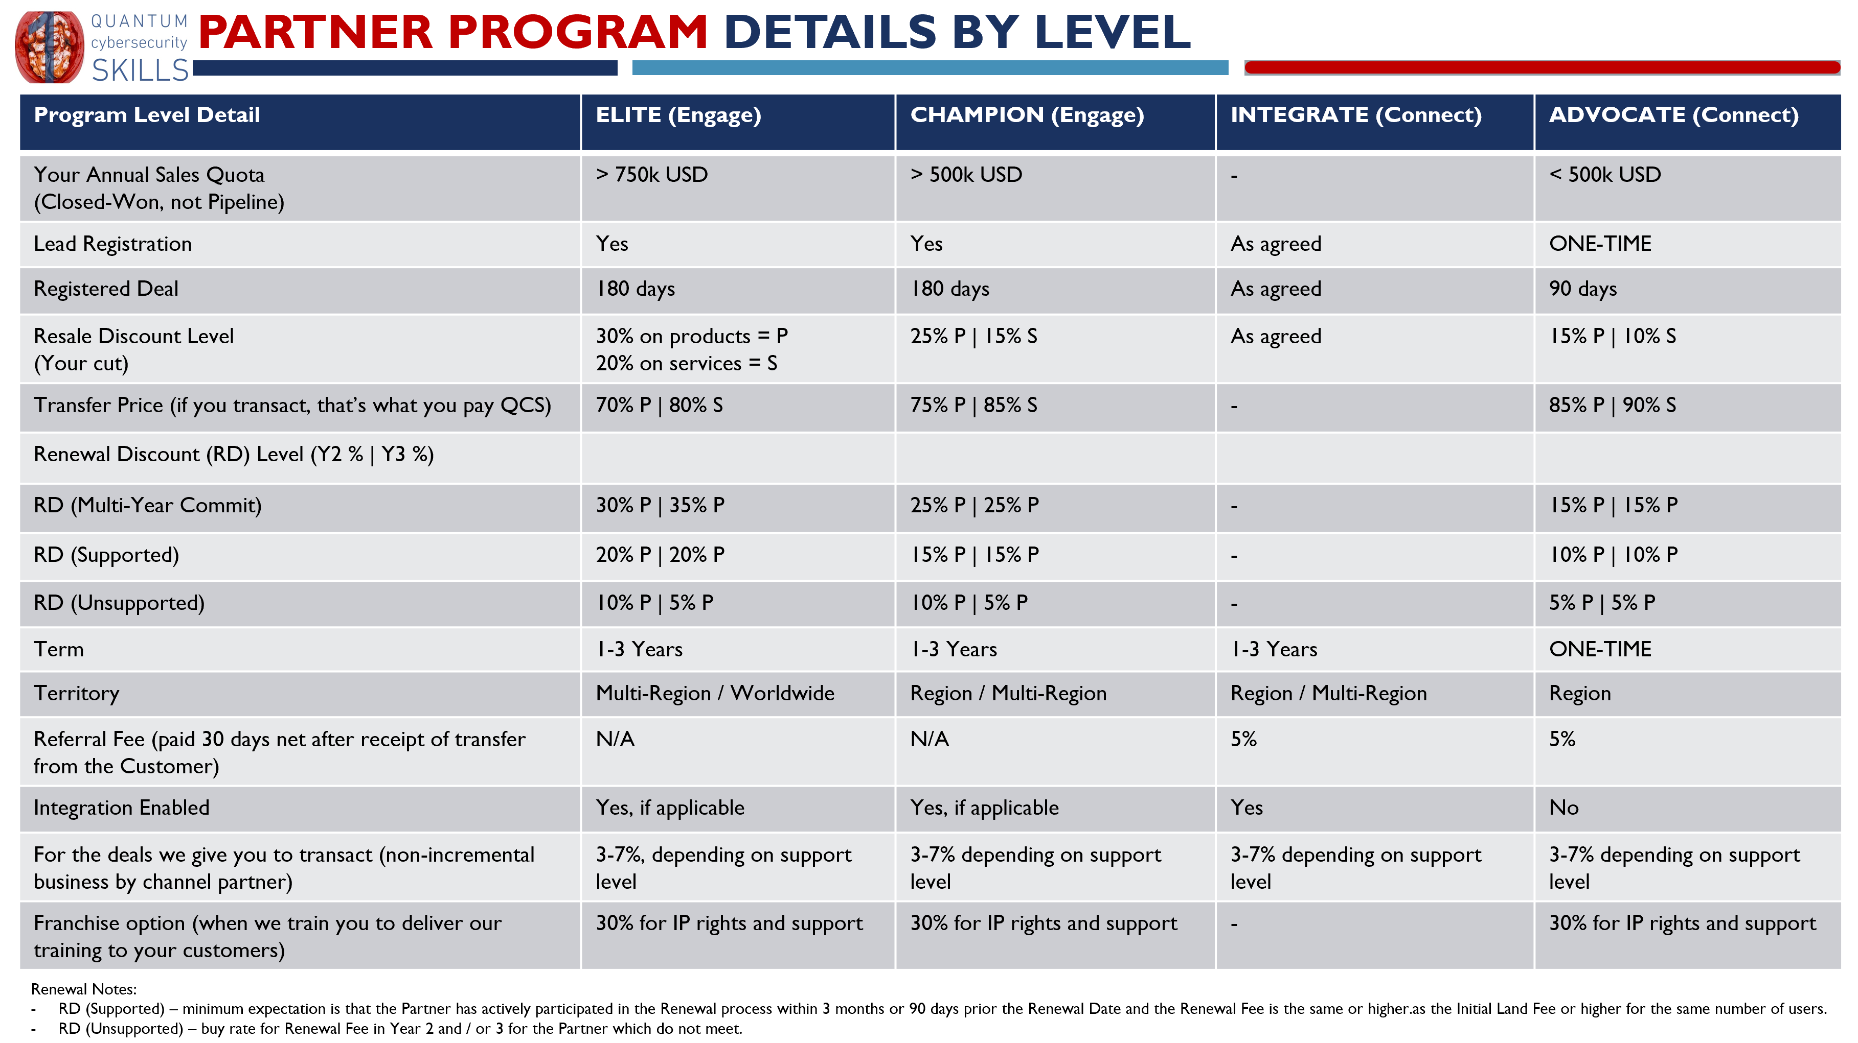
(Updated: NOV.2021)
Opportunity Registration:
Opportunities must be registered by completing the Opportunity Registration Form on QCS website or via email. Within five (5) business days of such registration, QCS shall provide the Reseller with notice via electronic mail confirming that the prospect opportunity has been registered (each a “Registered Opportunity”) or has been rejected. QCS may reject a prospect opportunity in its sole discretion including if (a) QCS has previously received notice from another Reseller identifying such opportunity, (b) QCS is in negotiations with the prospect on the same opportunity, or (c) QCS has had an existing business relationship with the prospect. Each Registered Opportunity shall retain such status for a period of six (6) months from the date of acceptance by QCS of the Opportunity Registration, unless otherwise agreed to in writing. At the expiration of the Registered Opportunity Period, The Reseller, at its option, may resubmit the opportunity via a new Opportunity Registration Form, and QCS shall accept or reject such request in accordance with the process described above. During the Registered Opportunity Period and solely during such period, Reseller shall be entitled to receive the enhanced discount rate specified above.
Appendix B
Certification Requirements

Not required for Reseller.

Appendix C
Reseller Bank Account Details

Beneficiary’s Full Name _______________________________________________________________
Beneficiary’s Phone No. ______________________________________________________________
Beneficiary’s Full Street Address (P.O. Box not permitted)
__________________________________________________________________________________
__________________________________________________________________________________
__________________________________________________________________________________
Postcode ____________________________ Country _______________________________________
Beneficiary’s Account Number or IBAN (IBAN required for payments outside UK)
__________________________________________________________________________________
Beneficiary Bank’s Name ______________________________________________________________
Beneficiary Bank’s Address ____________________________________________________________
__________________________________________________________________________________
Postcode ____________________________ Country _______________________________________
Bank Code (ABA Routing or Fedwire Number (USA) / Sort Code (UK) / Branch Code / SWIFT / BIC Code
__________________________________________________________________________________

Appendix D
Program Materials

- QCS Brochure
- QCS Terms & Conditions of Sale & Service Level Agreements
- QCS Presentation
- QCS Logo
- Link to other QCS collateral

